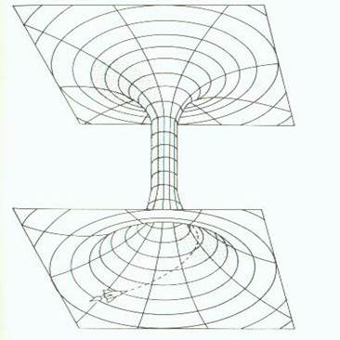
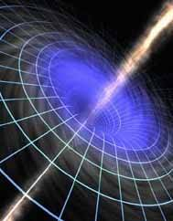
In 1936 , Einstein along with his collaborator Nathan Rosen, discovered a new implicit relation from the general relativity formalism. They attempted to explain that fundamental particles such as electrons as space tunnels threaded by electric lines of force. This tunnel like curved space acts like a shortcut between two distant regions of space and time.
Barely a few months after Einstein wrote down his equations, the first exact solution of the Einstein equations was found by Karl Schwarzschild. One of the remarkable predictions of Schwarzschild's equations was that if a mass M, were compressed inside a critical radius r_{s}, nowadays called the Schwarzschild radius (the farthest visible point), then its gravity would become so strong that not even light could escape. The Schwarzschild radius, r_{s,} of a mass, M, is given by:
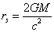
Now this confirmed that black holes are in a way an entrance to an Einstein-Rosen bridge. As we know that black hole is a region of space-time from which nothing can escape, even light. Black holes are the evolutionary endpoints of stars at least 10 to 15 times as massive as the Sun. If a star that massive or larger undergoes a supernova explosion, it can leave behind a fairly massive burned out stellar remnant (collective term used to describe the stars that are left when a High Mass Star or a Low Mass Star dies). With no outward forces to oppose gravitational forces, the remnant will collapses on itself. The star eventually collapses to the point of zero volume and infinite density, creating what is known as a “singularity”. As the density increases, the path of light rays emitted from the star are bent and eventually wrapped irrevocably around the star. Any emitted photons are trapped into an orbit by the intense gravitational field; they will never leave it. Because no light escapes after the star reaches this infinite density, it is called a black hole.
Curiously, the Schwarzschild radius had already been derived by John Michell in 1784. The English geologist realized that it would be theoretically possible for gravity to be so overwhelmingly strong that nothing, not even light could escape. To generate such gravity, an object would have to be very massive and unimaginably dense. At the time, the necessary conditions for "dark stars", as Michell called them, seemed physically impossible. His ideas were published by the French mathematician and philosopher Pierre Simon Laplace in two successive editions of an astronomy guide, but were dropped from the third edition. In Laplace's 1795 edition, he put forward the following equation saying what the mass and radius would have to be to form a black hole.
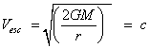
The complete Schwarzschild geometry consists of a black hole, a white hole, and two Universes connected at their horizons by a wormhole. It was actually Austrian Ludwig Flamm who had realized that Schwarzschild's solution (called the Schwarzschild Metric) to Einstein's equations actually describes a wormhole connecting two regions of flat space-time; two universes, or two parts of the same universe.
Now everyone knows what a black hole is, the thing which arouses our interest is the phenomenon of a white hole. A white hole (from the negative square root solution inside the horizon) is a black hole running backwards in time. Just as black holes swallow things irretrievably, so white holes spit them out. However white holes cannot exist, since they violate the second law of thermodynamics. This white hole is like an exit to the Einstein-Rosen Bridge.
The prediction of the existence of black holes did not trouble Einstein, but he found that the black holes contained a singularity at its center; this is a point of infinite density where time comes to an end. At the point of the singularity, all the known laws of physics start to breakdown. For Einstein this was a very troubling thought and he did not like them, the idea that they were shielding from the outside world by the event horizon of the black hole was not enough for him so he went to work with Nathan Rosen and in 1935 they produced a paper that produced evidence for a bridge between a black hole and a white hole, this was called the Einstein-Rosen Bridge.
This is how the Einstein-Rosen bridge theory developed and this has also inspired time travel and inter as well as intra universe travel. We saw it in the movie Thor where it linked Earth to Asgard. Some people think that time travel is possible while some are against the concept. Well, this is a mystery not yet unraveled and arouses a lot of questions among us.

